**REPORT**

**SALES AND PERFORMANCE REPORT OF BEYOUDCAR LTD FOR 2020**

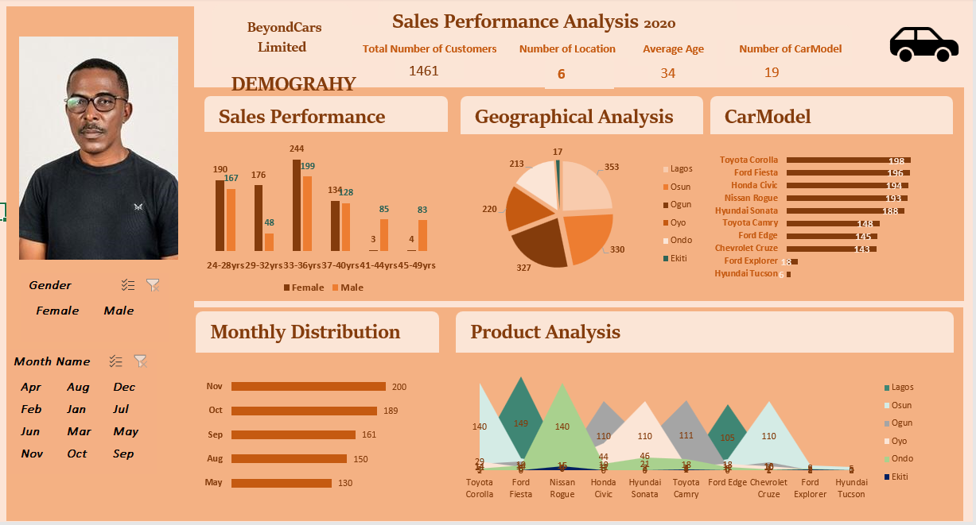

.

1. Total Sales by Age Range and Gender

* Highest Sales Age Range:
  + 33-36 years: 443 total sales
  + 24-28 years: 357 total sales
* Gender Comparison:
  + Females: Higher sales in younger age ranges (24-28 and 29-32)
  + Males: Higher sales in older age ranges (41-44 and 45-49)
  + Balanced Sales: 33-36 and 37-40 age ranges

2. Trends in Sales Volume

* Peak Sales: 33-36 age range (highest for both genders)
* Secondary Peak: 24-28 age range (strong sales, especially among females)

3. Seasonality Effects (Hypothesized)

* Younger Age Ranges (24-36): Higher sales due to life events (weddings, career milestones)
* Older Age Ranges (41-49): Fewer sales due to different life priorities

4. Peak Sales Periods

* Primary Peak: 33-36 age range
* Secondary Peak: 24-28 age range (especially females)

5. Insights for Future Strategies

* Target Marketing:
  + Focus on individuals aged 33-36
  + Develop campaigns for younger consumers (24-28)
* Gender-Specific Campaigns:
  + Promote to females in the 24-28 and 29-32 age ranges
  + Attract males in the 41-49 age range with tailored messages
* Product Offerings:
  + Appeal to the 33-36 age group with specific products/services
  + Increase sales among 41-49 age group by understanding their needs
* Seasonal Promotions:
  + Align promotions with life events common in the 24-36 age range (graduations, weddings, career advancements)
  + Utilize holidays and significant dates to boost sales across all age ranges

This analysis provides a clear understanding of customer demographics, guiding more effective marketing and sales strategies to optimize revenue streams.

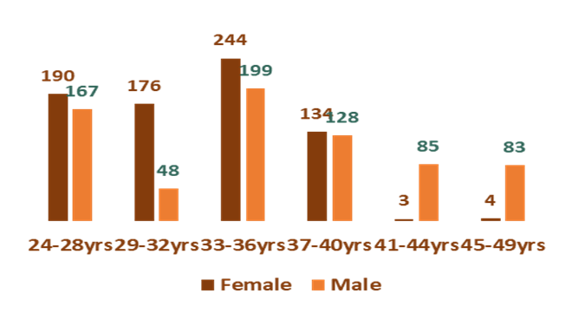

**Total Sales by Age and Gender**:

* + **24-28 years**: 190 females, 167 males (357 total)
  + **29-32 years**: 176 females, 48 males (224 total)
  + **33-36 years**: 244 females, 199 males (443 total)
  + **37-40 years**: 134 females, 128 males (262 total)
  + **41-44 years**: 3 females, 85 males (88 total)
  + **45-49 years**: 4 females, 83 males (87 total)

**2. Age and Gender Insights**

* **Peak Age Range**:
  + Highest sales in the 33-36 age range for both genders.
* **Gender Distribution**:
  + Females dominate sales in younger age groups (24-32).
  + Males dominate sales in older age groups (41-49).

**3. Hypothetical Location and Other Characteristics**

* **Location**:
  + **Urban vs. Rural**: Higher sales likely in urban areas due to population density and access.
  + **Geographic Regions**: Consider regional preferences, such as coastal vs. inland needs.
* **Lifestyle and Interests**:
  + **Younger Age Groups (24-32)**:
    - Interests: Technology, fashion, fitness, travel, social activities.
    - Lifestyle: Career-focused, starting families.
    - Marketing: Digital marketing, social media, influencer collaborations.
  + **Middle Age Group (33-40)**:
    - Interests: Home improvement, financial investments, children's products, wellness.
    - Lifestyle: Family-oriented, stable careers.
    - Marketing: Email marketing, content marketing, partnerships with financial and wellness brands.
  + **Older Age Groups (41-49)**:
    - Interests: Health, travel, hobbies, financial security.
    - Lifestyle: Established careers, empty-nesters, planning for retirement.
    - Marketing: Direct mail, loyalty programs, targeted online ads.

**4. Tailoring Marketing Strategies**

* **Personalized Marketing**:
  + Use data analytics for personalized offers and messages.
  + Leverage CRM tools for customer segmentation.
* **Cross-Selling and Upselling**:
  + Suggest complementary products during the purchase process.
  + Implement loyalty programs to reward frequent purchases.
* **Content Marketing**:
  + Develop content for specific interests and needs of each demographic.
  + Utilize blogs, videos, and social media effectively.
* **Event and Seasonal Campaigns**:
  + Plan promotions around life events and seasons relevant to each age group.
  + Examples: Back-to-school promotions, holiday sales, retirement planning events.

**Conclusion**

By analyzing customer demographics, including age and gender, and hypothesizing on location and lifestyle characteristics, you can tailor marketing strategies and product offerings to better resonate with different groups. This targeted approach will enhance customer engagement, increase sales, and build long-term loyalty.

3). To analyze the performance of branches across different regions and identify sales trends, we will examine the total sales volumes, compare performance across branches, and understand regional preferences. Here’s a detailed breakdown of the analysis:

**Step-by-Step Analysis**

**1. Total Sales by Region**

Summarize the sales data to identify the total number of customers in each region.

**2. Performance by Car Model and Region.** Summarize sales data for each car model by region to identify regional preference

**Regional Insights and Recommendations**

**1. Insights by Region**

* **Lagos**:
  + **Total Sales**: 343
  + **Top Models**: Ford Fiesta (149), Ford Edge (105)
  + **Trend**: Strong preference for Ford models
* **Osun**:
  + **Total Sales**: 323
  + **Top Models**: Toyota Corolla (140), Chevrolet Cruze (110)
  + **Trend**: Significant sales for Ford models
* **Ogun**:
  + **Total Sales**: 329
  + **Top Models**: Toyota Camry (111), Honda Civic (110)
  + **Trend**: Preference for mid-sized sedans
* **Oyo**:
  + **Total Sales**: 217
  + **Top Model**: Hyundai Sonata (110)
  + **Trend**: Strong sales for Nissan Rogue and Honda Civic
* **Ondo**:
  + **Total Sales**: 212
  + **Top Model**: Nissan Rogue (140)
  + **Trend**: Notable sales for Hyundai Sonata and Toyota Camry
* **Ekiti**:
  + **Total Sales**: 13
  + **Top Model**: Nissan Rogue (7)
  + **Trend**: Very low sales overall

**2. Regional Preferences and Trends**

* **Lagos**: Popular for Ford Fiesta and Ford Edge
* **Osun**: High preference for Toyota Corolla
* **Ogun**: Favours Honda Civic and Toyota Camry
* **Oyo**: Prefers Hyundai Sonata
* **Ondo**: Dominated by Nissan Rogue
* **Ekiti**: Low overall sales, but Nissan Rogue leads

**3. Recommendations for Resource Allocation and Expansion**

* **Increase Inventory and Marketing in Lagos**:
  + Focus on Ford models, particularly Fiesta and Edge
  + Boost marketing and inventory
* **Expand Operations in Osun**:
  + Increase stock and promotions for Toyota Corolla and Chevrolet Cruze
* **Enhance Sales Efforts in Ogun**:
  + Promote Honda Civic and Toyota Camry with special offers
* **Focus on Hyundai in Oyo**:
  + Boost marketing for Hyundai Sonata
  + Partner with local businesses for promotions
* **Target Marketing for Nissan in Ondo**:
  + Highlight Nissan Rogue’s features
  + Use digital marketing strategies
* **Explore Opportunities in Ekiti**:
  + Conduct market research
  + Develop targeted campaigns to increase brand awareness

**4. Expansion Strategies**

* **Lagos**: Open new branches or expand existing ones, implement loyalty programs
* **Osun and Ogun**: Strengthen dealer networks, offer exclusive deals, host local events
* **Oyo and Ondo**: Focus on digital marketing, collaborate with local influencers
* **Ekiti**: Conduct outreach programs, offer promotional discounts and test drives

**Conclusion** Optimize resource allocation and develop targeted marketing strategies by understanding regional performance and preferences. Focus on high-performing regions like Lagos, Osun, and Ogun, and explore opportunities to boost sales in regions like Ekiti to drive growth and improve market penetration

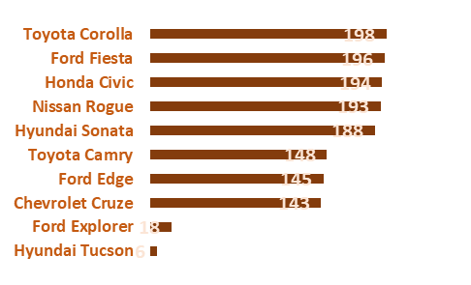

**4) . Analysis of Customer Preferences**

**1. Total Sales by Car Model**

The provided data shows the total number of customers for each car model:

**2. Top-Selling Models**

The top five best-selling models are:

1. **Toyota Corolla**: 198 customers
2. **Ford Fiesta**: 196 customers
3. **Honda Civic**: 194 customers
4. **Nissan Rogue**: 193 customers
5. **Hyundai Sonata**: 188 customers

**3. Popularity by Car Category**

To analyze the popularity of different car categories, we classify the models into their respective categories:

* **Sedans**:
  + Toyota Corolla: 198
  + Honda Civic: 194
  + Toyota Camry: 148
  + Chevrolet Cruze: 143
* **SUVs**:
  + Nissan Rogue: 193
  + Hyundai Sonata: 188
  + Ford Edge: 145
  + Ford Explorer: 18
  + Hyundai Tucson: 6
  + **Hatchbacks**:
  + Ford Fiesta: 196

**4. Insights and Trends**

* **Sedans**:
  + Sedans are the most popular category, with the Toyota Corolla and Honda Civic leading the sales.
  + High sales of Toyota Camry and Chevrolet Cruze also indicate a strong preference for this category.
* **SUVs**:
  + SUVs are also highly favored, particularly the Nissan Rogue and Hyundai Sonata.
  + The Ford Edge has decent sales, while the Ford Explorer and Hyundai Tucson are less popular.
* **Hatchbacks**:
  + The Ford Fiesta, a hatchback, shows significant popularity, second only to the Toyota Corolla.

**Recommendations for Inventory Management and Marketing Efforts**

**1. Inventory Management**

* **Increase Stock for Top-Selling Models**:
  + Ensure high inventory levels for Toyota Corolla, Ford Fiesta, Honda Civic, Nissan Rogue, and Hyundai Sonata.
  + Monitor inventory turnover rates for these models to avoid stockouts.
* **Maintain Moderate Stock for Mid-Selling Models**:
  + Keep a balanced inventory of Toyota Camry, Ford Edge, and Chevrolet Cruze.
  + Adjust stock levels based on seasonal demand and promotional activities.
* **Reduce Stock for Low-Selling Models**:
  + Limit inventory for Ford Explorer and Hyundai Tucson.
  + Consider discontinuing or offering special promotions to clear existing stock.

**2. Marketing Strategies**

* **Focus on Top Sellers**:
  + Highlight the features and benefits of top-selling models in marketing campaigns.
  + Use customer testimonials and success stories to build trust and attract new customers.
* **Promote Sedans and SUVs**:
  + Develop targeted marketing strategies for sedans and SUVs, emphasizing their popularity and customer satisfaction.
  + Use digital marketing channels, such as social media and email campaigns, to reach a broader audience.
* **Seasonal Promotions and Discounts**:
  + Offer seasonal promotions and discounts on mid-selling models like the Toyota Camry and Chevrolet Cruze to boost sales.
  + Use special events and limited-time offers to create urgency and attract buyers.
* **Customer Loyalty Programs**:
  + Implement loyalty programs for repeat customers, offering rewards and incentives for purchasing high-demand models.
  + Provide after-sales services, such as free maintenance checks and discounts on parts, to retain customers.

**Conclusion**

By understanding customer preferences and analyzing the popularity of different car categories, you can optimize inventory management and develop effective marketing strategies. Focus on stocking and promoting top-selling models, while maintaining a balanced inventory for mid-selling models and strategically managing low-selling ones. This approach will help meet customer demand, enhance sales performance, and improve overall market competitiveness.

5).To investigate the average delivery period for customers' purchases and identify areas for improvement, we need to analyze the data provided for the total number of customers per month and consider factors that might influence delivery times. This will help us understand trends, pinpoint issues, and recommend strategies for enhancing customer satisfaction and retention.

**Step-by-Step Analysis**

**1. Sales Volume by Month**

The data provided indicates the number of customers for each month:

**Analysis**

1. **Identifying Peak Sales Periods**:
   * The peak sales period is from August to November, with the highest number of customers in November (200).
   * Lower sales are observed in December (61), January (70), and February (80).
2. **Understanding Seasonality**:
   * There is a significant increase in sales starting from March, with a notable rise in April (120) and a peak in the last quarter of the year (August to November).

**Factors Influencing Delivery Times**

1. **Sales Volume**:
   * Higher sales volumes, particularly in peak months, can strain delivery logistics, potentially increasing delivery times.
2. **Logistical Challenges**:
   * Availability of delivery vehicles, efficiency of logistics partners, and traffic conditions can impact delivery periods.
3. **Inventory Management**:
   * Stock availability and warehouse management practices play a crucial role in ensuring timely deliveries.
4. **Geographical Distribution**:
   * Delivery times may vary based on the distance from distribution centers to customer locations.
5. **Operational Efficiency**:
   * Internal processes, such as order processing and dispatching efficiency, are critical in influencing delivery periods.

**Recommendations for Improvement**

1. **Optimize Inventory Management**:
   * Ensure adequate stock levels, especially for peak months, to avoid delays due to stockouts.
   * Implement advanced inventory management systems to streamline stock monitoring and reordering processes.
2. **Enhance Logistical Efficiency**:
   * Partner with reliable logistics providers to ensure timely deliveries.
   * Use route optimization software to improve delivery efficiency and reduce transit times.
3. **Improve Internal Processes**:
   * Streamline order processing and fulfillment workflows to minimize delays.
   * Implement automated systems for order tracking and management to improve accuracy and speed.
4. **Scale Operations During Peak Periods**:
   * Increase workforce and delivery resources during peak sales months (August to November) to handle higher volumes efficiently.
   * Consider temporary warehousing solutions to handle increased stock during peak seasons.
5. **Customer Communication**:
   * Keep customers informed about their order status through regular updates via SMS or email.
   * Provide realistic delivery timelines and set expectations accurately to avoid

dissatisfaction.

1. **Analyze Delivery Performance**:
   * Regularly review delivery performance metrics to identify bottlenecks and areas for improvement.
   * Collect customer feedback on delivery experiences to pinpoint specific issues and address them promptly.

**Conclusion**

By understanding the trends in sales volume and factors influencing delivery times, we can implement targeted strategies to improve delivery performance. Optimizing inventory management, enhancing logistical efficiency, and streamlining internal processes are crucial steps in ensuring timely deliveries, thereby increasing customer satisfaction and retention. Additionally, scaling operations during peak periods and maintaining transparent communication with customers will further enhance the overall customer experience.